Step 1: Download or copy and paste **the QA Web Standards Reporting Tool V1** package to the root of the C drive

Step 2: Click on the **InstallationSetUp.bat** file. A QA-WS-tool folder and sub-folder are created. 5 files are also added.

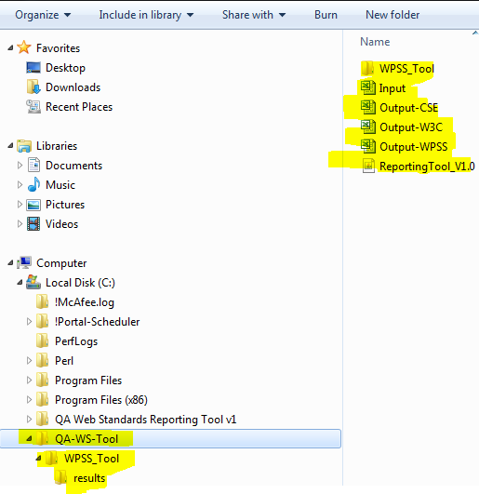

Step 3: Right-click on WPSS_Install3_10_0.exe file and Install **Run as Administrator** to install WPSS, Python and Active Pearl Software

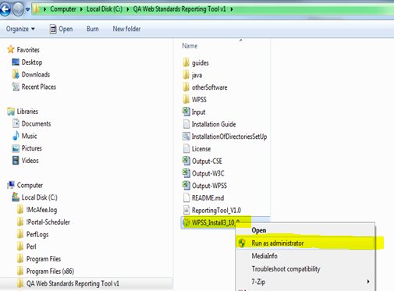

Step 4: Select language

Step 5: Click **Yes** to install Pearl

Step 6: Click **Next** to Install Active Perl

Step 7: Select radio box to accept terms of licence and click **Next**

Step 8: Click **Next** then **Next** then **Install**

Step 9: Click **Finish**

Step 10: Click **Next** install the WPSS tool and Install at default location: C:\Program Files (x86)\WPSS_Tool

Step 11: Click **Install**

Step 12: Click **Close**

Step 13: Click **Next** then **Next** then **Next** to install Python

Step 14: Click **Finish**

Step 15: Install CSE HTML Validator. Click on **cse-html-validator-140020pro-set-up.exe** file found in the **otherSoftware** sub folder in the main package.

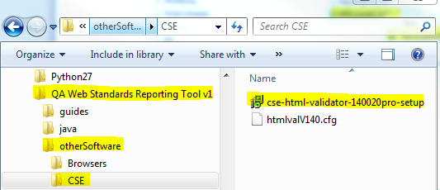

Step 16: Click **Next**

Step 17: Click **I Accept** for Licence Terms and Condition

Step 18: Click **Next** then **Next** then **Next** then **Install**

Step 19: Click **Exit**

Step 20: Uncheck Editor Options. Select Options **>Editor Options** then go to **Startup** file

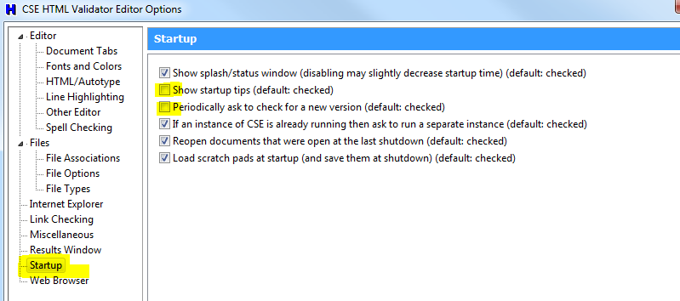

Step 21: Enable Accessibility Checking. Select **Options > Validator Engine Options > Enable Accessibility Checking**

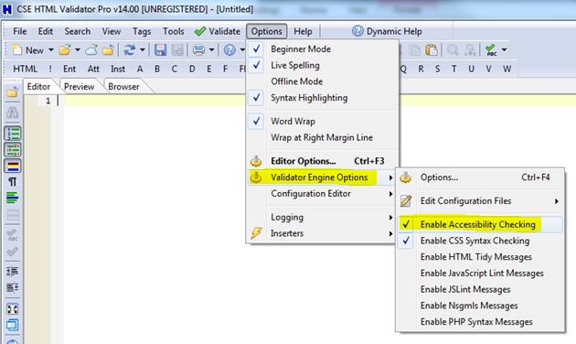

Step 22: Reboot Computer.

Step 24: Start reporting by clicking on the **ReportingToolV 1.0.jar** file

Step 25: Install Firefox and Add-ons in sequence

http://www.mozilla.org/en-US/firefox/features/

https://addons.mozilla.org/en-US/firefox/addon/60

https://addons.mozilla.org/en-US/firefox/addon/wave-toolbar/?src=ss

https://addons.mozilla.org/en-US/firefox/addon/wcag-contrast-checker/?src=ss

https://addons.mozilla.org/en-US/firefox/addon/juicy-studio-accessibility-too/?src=ss

https://addons.mozilla.org/en-US/firefox/addon/colorzilla/?src=ss

https://addons.mozilla.org/en-US/firefox/addon/firebug/?src=ss

https://addons.mozilla.org/en-us/firefox/addon/openajax-accessibility-exte/versions/

https://addons.mozilla.org/en-US/firefox/addon/accessibility-evaluation-toolb/?src=search

NOTE: Environment must be Window 7 and Internet Exploer 9